We live in a world that is largely male dominated, and because it is dominated by men, women are often pigeon-held to certain stereotypes. This is especially true, and is probably most recognizable, when it comes to sports. From an early age, girls are taught that boys play sports, and athleticism is a masculine thing. Phrases like “you throw like a girl” exists, brainwashing girls into believing they are not good at something before even trying it. This mind-set is incredibly damaging to girls of all backgrounds, but imagine how damaging it can be when a girl is living in poverty and told so many other things as well. Through Girl Effects’ new brand, Throw Like a Girl, digital media will be used to empower teenage girls living in poverty within the UK through sports and create a more positive platform for them online.

There have been countless studies that have shown that participating in sports and physical activity leads to healthier lifestyle habits and helps with stress and anxiety. Yet there have also been studies that show adolescents living in poverty are less likely to participate in sports and physical activity, and more likely to suffer from mental illnesses such as stress and anxiety (Joseph Rowntree Foundation and Power). Some reasons that are listed for why they do not participate include costs and accessibility. When comparing these studies to search trends, it shows how the brand Throw Like a Girl can have an important influence on an audience that is often forgotten. Yet before this brand can be dissected, there must first be an understanding of the target audience:
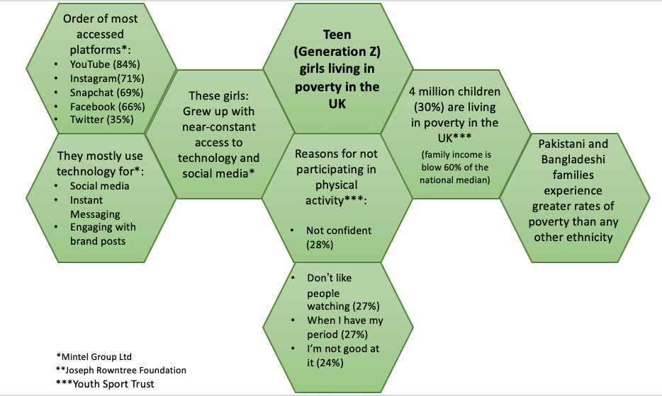
Target Audience

Because our target audience is largely based online, as well as lacks the confidence to participate in sports, creating the right platforms will be vital. As such, there will be two main topics for the brand Throw Like a Girl, which will be that an important factor for making this campaign successful in empowering girls who are living in poverty through sports.

The first topic will be bringing sports and physical activity directly to our audience. As Power’s study on sports and poverty has shown, the most successful projects have been those that go directly to the doors of children living in poverty. In doing so, pick-up games can be created, and it gives the children a chance to enjoy sports in an environment that is not focused solely on competition. Nor will they have to worry about spending money to participate, or find means to get to a certain location. An example that can be power of accessibility outweighing cost can be seen through the Swim-for-Life Foundation in the Snohomish School district, Washington, US. This program offers free swim lessons to all second graders within the school district. Yet out of 669 students, only 66 have signed up for the program so far this year (McCall, Guest Service Manager for Snohomish Aquatics Center, where the lessons for Swim for Life foundation are held), this could be because of the distance many parents have to drive in order to get their child to their lessons.

As the target audience are teenagers whose lives often revolve around digital media, creating a digital platform where the girls can create local pick-up games and sports teams will prove vital for Throw Like a Girl’s success. Partnerships with organizations such as Football Beyond Borders and Street Games will help in creating these local pick-up games and teams, as it is what they already do. Partnerships such as these will prove useful as they already have their social media platform developed, and we can use it as a way to spread the word about Throw Like a Girl. Football Beyond Borders, for example, has over 10 thousand followers on Instagram, with constant active engagement on posts. By using it’s social media platform, it will help us reach a wider audience and bring more attention and engagement to our digital platforms and social media pages. A partnership with organisations such as these will be possible since they do not currently do not have a campaign that targets teenage girls directly, let alone one that focuses on those living in poverty. As the aim for the first topic of this brand is to inspire more girls to participate in sports, working together with other brands will help make ours more successful.

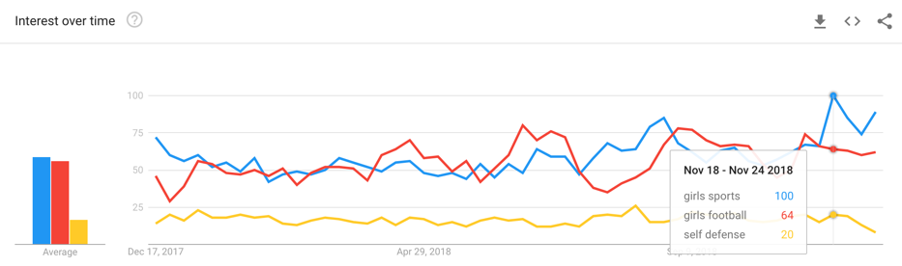
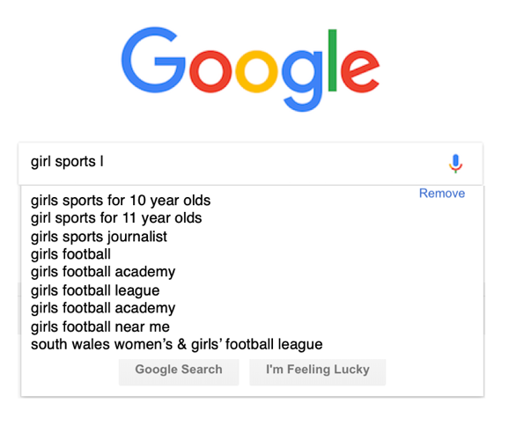
With as many sports that exist, an important question to ask is what sports Throw Like a Girl should focus on. Social listening tool Keyword.io shows that there are many search results that are popular in the UK that centre around girls’ sports. This is further backed up with the search trends found on Google, which can be seen below.

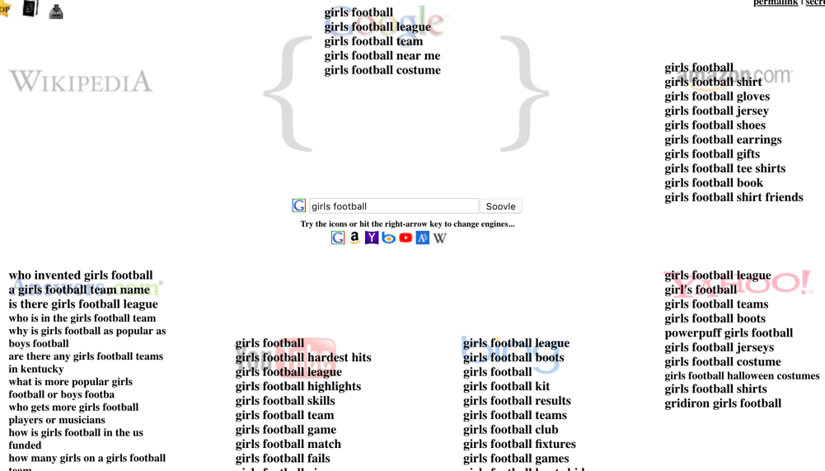
Social Media listener Soovle also shows the related search results for girls’ football across multiple search engines, with some of the most popular search results focusing on finding teams nearby.

Unpacking this data, it shows that Throw Like a Girl has a large platform for reaching girls who are interested in sports, but don’t know how to join or lack the confidence. While these data only focus on football and self defense, the brand can pick up any sport or physical activity as they become popular.

The second topic that will be an important factor for this new brand is giving girls the platform to challenge the stereotypical and derogatory ways female athletes are represented in the media. Social Listening tool Buzzsumo shows how articles that focused on female athletes’ accomplishments in a positive way have been incredibly popular.
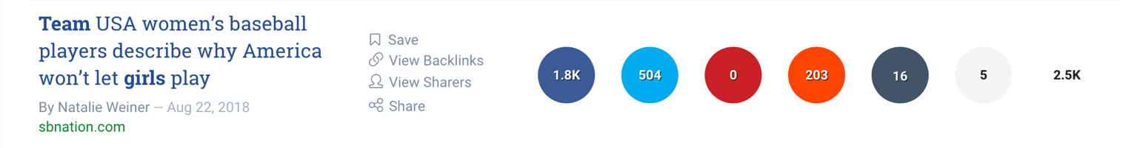
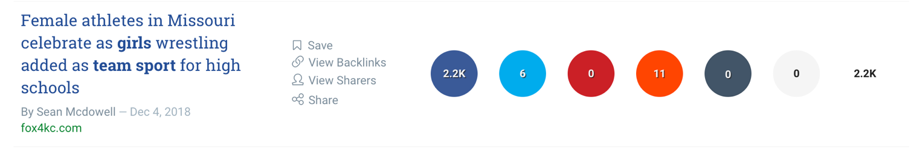

Because our target audience is largely influenced by social media, using influencers will not only help inspire girls to participate in sports and challenge the harmful ways female athletes are represented in, but will also help them in all aspects of life. As such, choosing which female athletes will be used as influencers will have to be done carefully by choosing someone that the target audience can relate to and look up to at the same time. As such, the following three women are possible candidates to be influencers for the Throw Like a Girl brand.
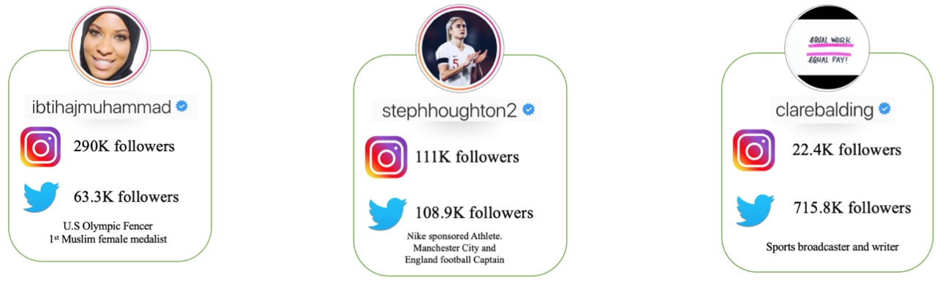
Ibtihaj Muhammad is a hijab wearing athlete, who received world-wide attention at the 2016 Olympics for being the first Muslim female medalist. Having an influencer like her will help hijab wearing girls feel like they can participate in sports as well. Since the Pakistani and Bangladeshi families experience the greatest poverty rates in the UK, Muhammad will be able to reach a wide audience in a way few other female athletes can. Steph Houghton is a successful British football player, and is captain for Manchester City and England football team. As football is one of the most popular sports, having an influencer like Houghton will inspire girls interested in football to join a club or create their own pick-up games. Clare Balding is a sports broadcaster and a huge advocate for female athletes. Having her as an influencer will help the target audience find their voice in challenging the ways female athletes are represented in the media.

Working and partnering with influencers like these and other organizations—like what was mentioned earlier—will provide a useful way to measure the reach of Throw Like a Girl. One way we can measure this reach is though the key performance indicator (KPI) of follower increase for our brands digital platforms as well as for the Instagram and Twitter accounts for our influencers and partnered organizations. Another KPI that can be used is amount of likes, comments and reposts of published content. When comparing the amount of liked, commented, and re-posted content with the follower increase, we can gage how many of our audiences our actively and consistently engaged with our published content and digital platforms. We can also use Google Trends as a KPI to measure discourse and search trends on our brand. Since our target audience is largely based on social media, using KPI’s to measure hashtags and tagging will give more insight to our reach. These KPI’s will also help us understand what sports our audience are interested in, and help plan future campaigns and projects for the Throw Like a Girl brand. Sports is a great way to build self-esteem and healthy life-style habits, and by using the digital platforms that teenagers can be found on, Throw Like a Girl has the potential to give girls living in poverty the empowerment they need to be successful in life.

Sources Used:
Barnard, et al. UK Poverty 2018, A comprehensive Analysis of poverty trends and figures. 2018. Joseph Rowntree Foundation
Buzzsumo
Google Trends
Keyword.io
Mintel Group Ltd. Technology Habits of Generation Z. 2018.
Power, A. Sport and Poverty. 2015.
Soovle

