Gabriella Axelson
Professor Amoshaun Toft
BISMCS 333, T/H 8:45
12 April 2016
Midterm: Annotate, Animate, Tweet!

The Business of Media, by David Croteau
Annotate:
In Croteau’s first chapter of The Business of Media, “Media, Markets, and the Public Sphere,” he explains the difference between the Market model and Public Sphere model, and why the public sphere model is more important in terms of explaining and representing media as a form of market. The public sphere, Croteau explains, shows how media “operate[s] in what is called a dual market . . . [by] simultaneously sell[ing] two completely different types of ‘products’ to two completely different sets of buyers,” thus developing a unique relationship where the media market is not responsive to its consumers, and instead are resources for the consumers to use (28). It is through this understanding of media as a form of market, along with the relationships between consumer, that Croteau shows how “market-oriented media have a tendency to produce economic benefits and simultaneously create (at least to help sustain) democratic deficits” along with influencing the surrounding societies (26).
Due to these evaluations and explanations, Croteau becomes a vital source for me to better understand the study of media and communications. He shows how media can act as a form of market, and explains why media can sustain or change our viewpoints. It emphasizes the importance of mainstream media, yet also the importance of knowing your target audience and what it is you want to accomplish.
Animate:
Media plays a large role in marketing. As Croteau showed in The Business of Media, it has the ability to sustain or change societies viewpoints. It is from this understanding I decided to create an image that showcased how media impacts our society. I chose hands to represent media and the “market,” as they are what “shapes” society. However, because media “shapes” society based on the normatives, along with how markets supply what is in demand, I represented the consumer as a piece of clay. I chose clay because it has the ability to change shape over and over again, yet never loses its consistency. This goes along with Croteau’s ideas that the market thrives on the supply and demand of consumers, and how media produce economic benefits and create democratic deficits.

Representation: Cultural Representation and Signifying Practices, by: Stuart Hall
Annotate:
Representation, according to Hall, is “the production of the meaning of concepts and language which enables us to refer to either the ‘real’ world of objects, people, or events, or indeed the imaginary worlds of fictional objects, people, and events” (17). With this definition of representation comes three theories: reflective, in which a meaning already exists; intentional, where language is expressed only though which he or she personally intended to mean; constructionist, where “meaning is constructed in and through language” (15). Hall claims that this third theory of constructionist is the best explanation of representation, which is supported by the two types of systems. The explains mental representations are how one is able to interpret the world as meaningful. The second “depends on constructing a set of correspondences between our conceptual map and set of signs, arranged or organized into various languages which stand for or represent those concepts” (19).
This reading therefore helps me better understand the complexity of communication. Not only is it the process of interpreting meaningful words, but also connecting through a shared language, symbol, or idea, which I think proves the importance of media.

Tweet:
For this article, I decided to use a tweet that proves as an example of representation while explaining what representation is as well. Many people are unaware of the complexity of communication and representation. Therefor I decide to focus on this in my tweet, by using a short enough text that engages the audience and causes them to want to learn more, while still showing the complexity of the topic.

Re:imagining Change. An introduction to story-based strategy
by: Doyle Canning and Patrick Reinsborough
Annotate:
Canning and Reinsborough explain a narrative power analysis to be one that “recognizes that humans understand the world and our role in it through stories,” which creates all power relations with a narrative dimension” (5). Because we live in a world that is shaped by stories, the narrative power analysis forces us to ask what stories define cultural norms and where these stories came from. These understandings allow us to use stories as a powerful force. This is because there are many stories, such as myths, where they leave out certain information and create underlying assumptions, which proves how the power of media can shape the point of view. Narrative power, therefore, can reach people with a message, which can be applied to branding as well as the creation of memes.
This article helped me gain a better understanding of the importance of story-telling, as it is a large form of communication. Yet to be able to adequately communicate with a target audience, one must have an excellent understanding of the facts, origins, and reasoning for the creation of any story, which in turn will help us create stories that the audience will be receptive towards.

Animate:
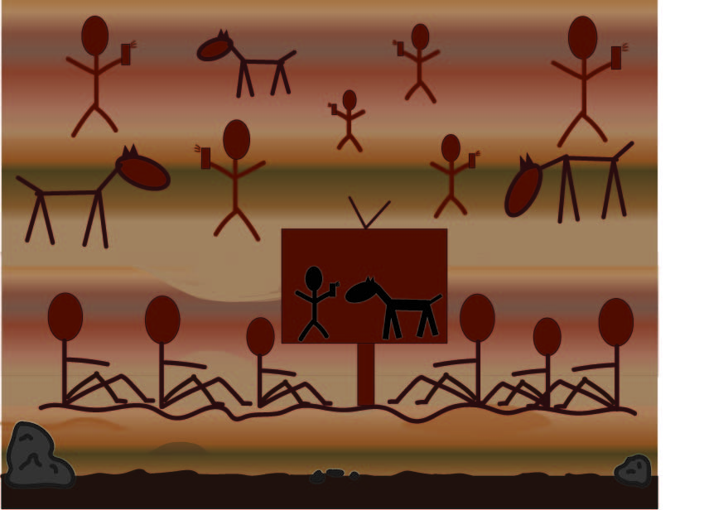
Canning and Reinsborough explained in Re:imagining Change how narrative power analysis and all story telling is largely ingrained into our society. But with todays technological advances, many of the stories we hear and see come from our phones, T.V’s, or computers. Therefore, I decided to create an image that many people associate with an old example of story telling: cave paintings. Yet to show the relevance to today, I created a scene depicting humans interacting with technologies (such as cell phones, cameras, and television) to represent our new way of receiving stories.

Images used:
Clay: https://danny61.files.wordpress.com/2011/07/clay.jpg
Hands: https://www.google.com/url?sa=i&rct=j&q=&esrc=s&source=images&cd=&ved=0ahUKEwiLoaP83IjMAhVHyWMKHdRsCIoQjRwIBw&url=https%3A%2F%2Fwww.flickr.com%2Fphotos%2F45490379%40N08%2Fgalleries%2F72157627549622373%2F&bvm=bv.119408272,d.cGc&psig=AFQjCNHJ5gvKVki-JDjnPW6SHfNl7nPhEg&ust=1460531702935274&cad=rjt

